HOW TO INSTALL AND CONFIGURE CENTOS7

1. Verify Network by running cmd and typing “ipconfig” (do not use the quotes).

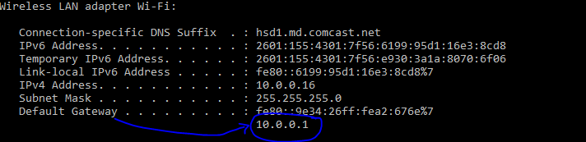

1. Note your gateway because your network is derived from the first three octets (10.0.0) after the last dot (.) you can start adding your host address, like 10.0.0.240. If your network is say Verizon, the gateway will look like this (192.168.1.1).
2. Next we name our server. We build two kinds of servers
3. Dynamic server which receives its ip address from the router i.e c7duser1. In place of user1 insert your username.
4. Next is the static server with ip given by you.

8 Static Servers

c7slydia0 192.168.1.240

c7slydia1 192.168.1.241

c7slydia2 192.168.1.242

c7slydia3 192.168.1.243

c7suser14 10.0.0.244

c7suser15 10.0.0.245

c7suser16 10.0.0.246

c7suser17 10.0.0.247

1. Then we plan our build of the server just like an architect plans out a house.

Storage Total Size **26GiB**

Partitions

**/boot** = **512MiB**

**/** = **12GiB**

**swap** = **1GiB**

**/var** = **9GiB**

**/home** = **2GiB**

**/lab** = **1GiB**

1. Earmark Memory size

Memory = **1024MB**

1. Also note the primary users to be created during the installation (no capital letters)

Users

root password = centos1

user1 password = user11

Planning done let’s build the server.

1. 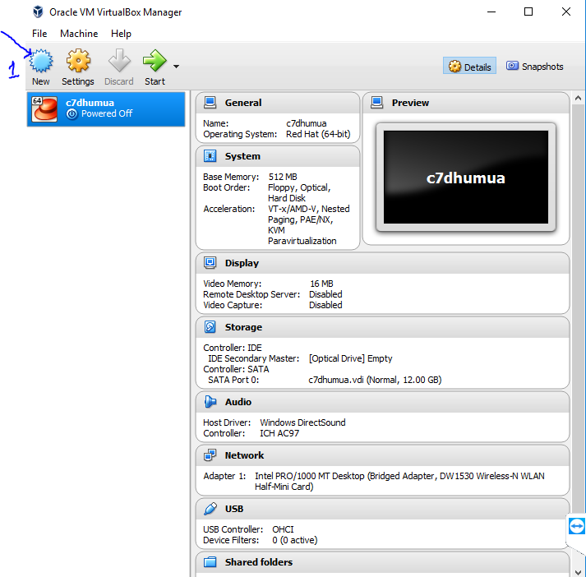
2. Insert name of server, type = Linux and version = red hat (64-bit)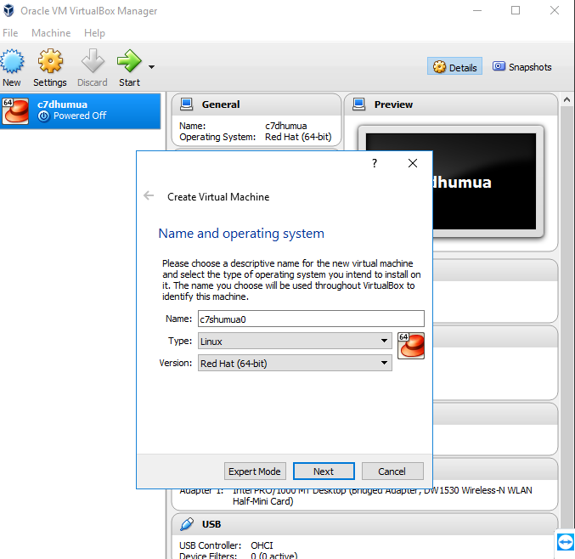
3. Click next for “Memory size” 1024MB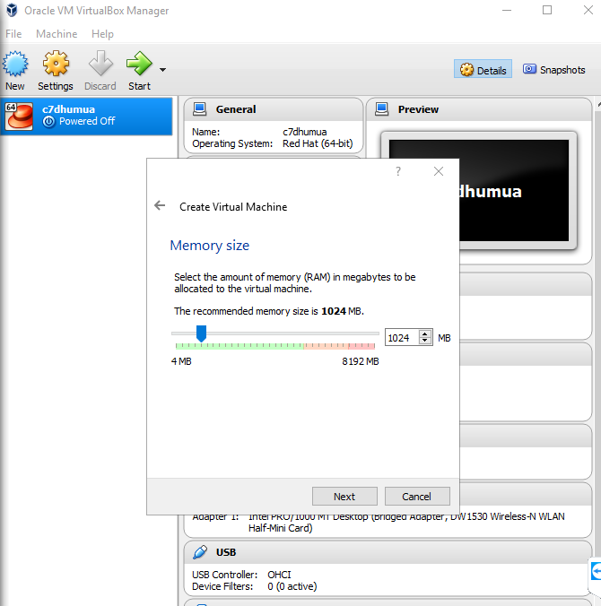
4. Click Next to “Create Virtual Machine” then click “Create”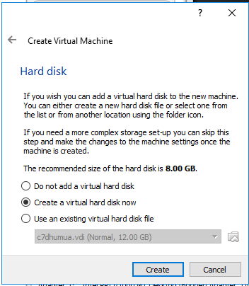
5. Click next to create VDI Virtual Hard Disk 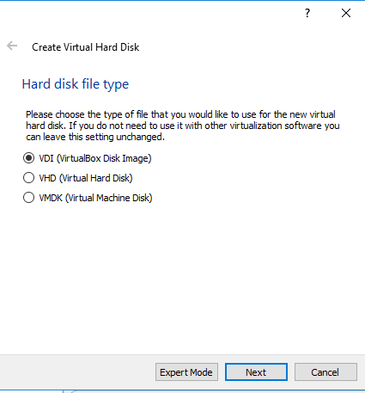
6. Click next to choose “Dynamically allocated” hard disk 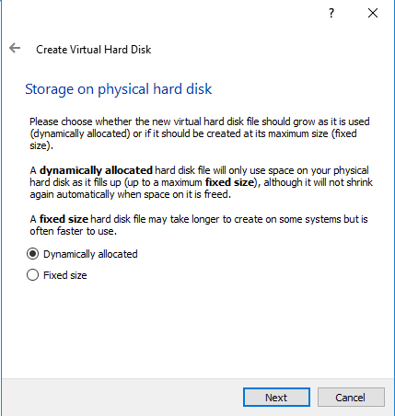
7. Next double click on 8GB and insert 26GB 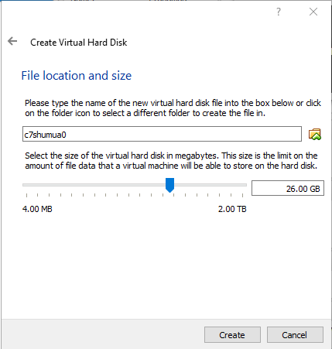
8. Click “Create” to complete the creation of hard disk. 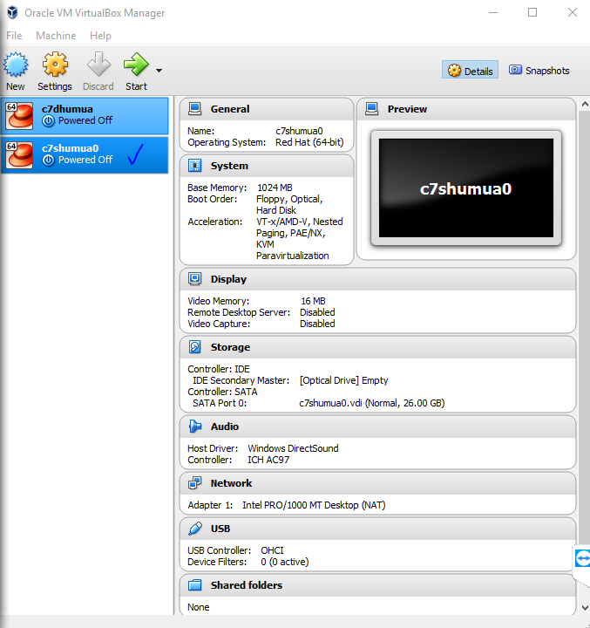
9. Next we set network to “Bridged Adapter” mode. Step 1, Highlight the chosen server, step2 click on network, step3 highlight network and step4 change “NAT” to “Bridged Adapter” 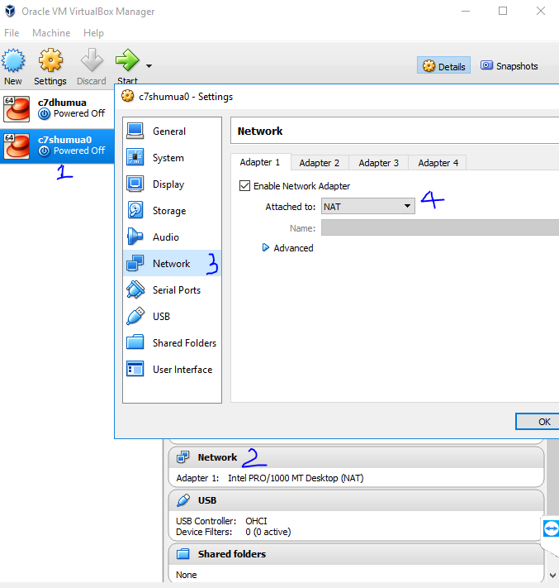
10. Step Choose “Bridged Adapter” and hit “ok” 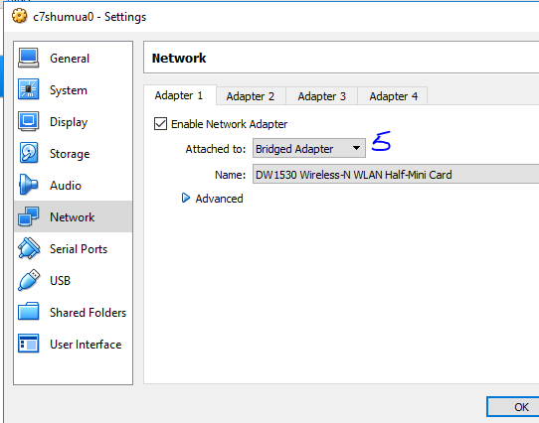
11. Now we can “START” by clicking the GREEN arrow 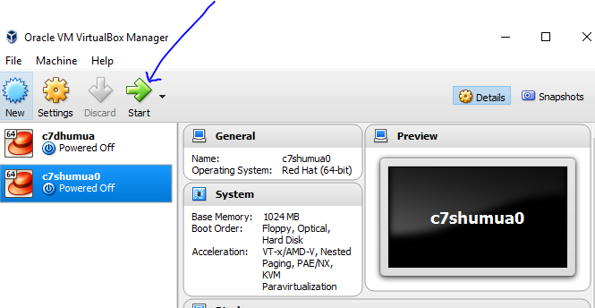
12. To select Start-up disk click on the yellow folder icon and locate “CentOS-7-X86-64-dvd-1611” and then click open 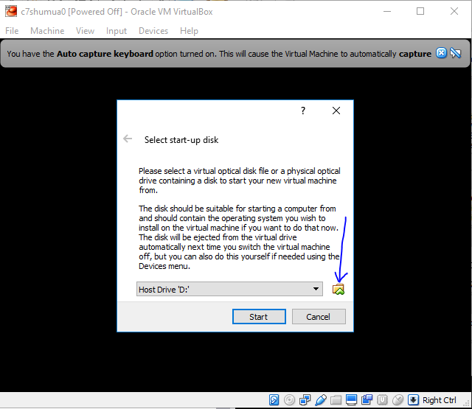
13. 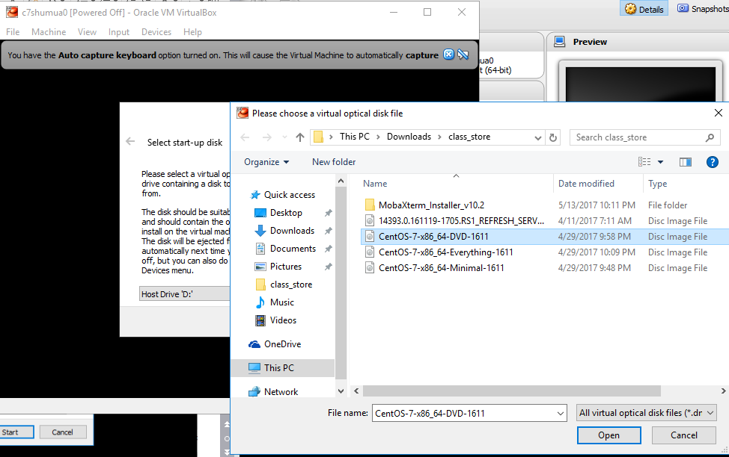
14. Click start

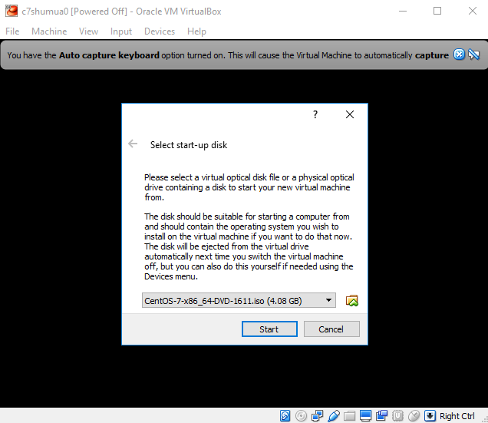

1. Use top arrow on your keyboard to select “Install CentOS Linux 7”

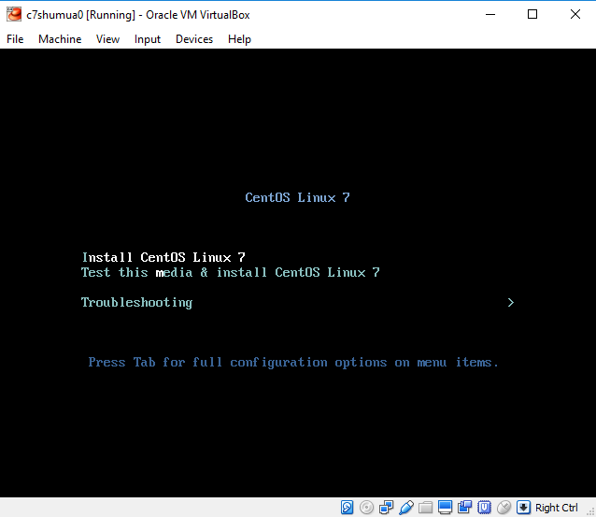

And hit “ENTER” on your keyboard.

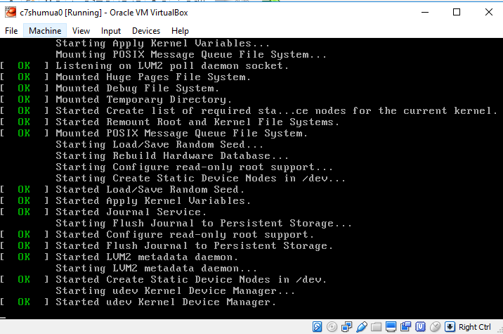

1. Once your cursor is captured please use the “Right CTRL” key to release your mouse

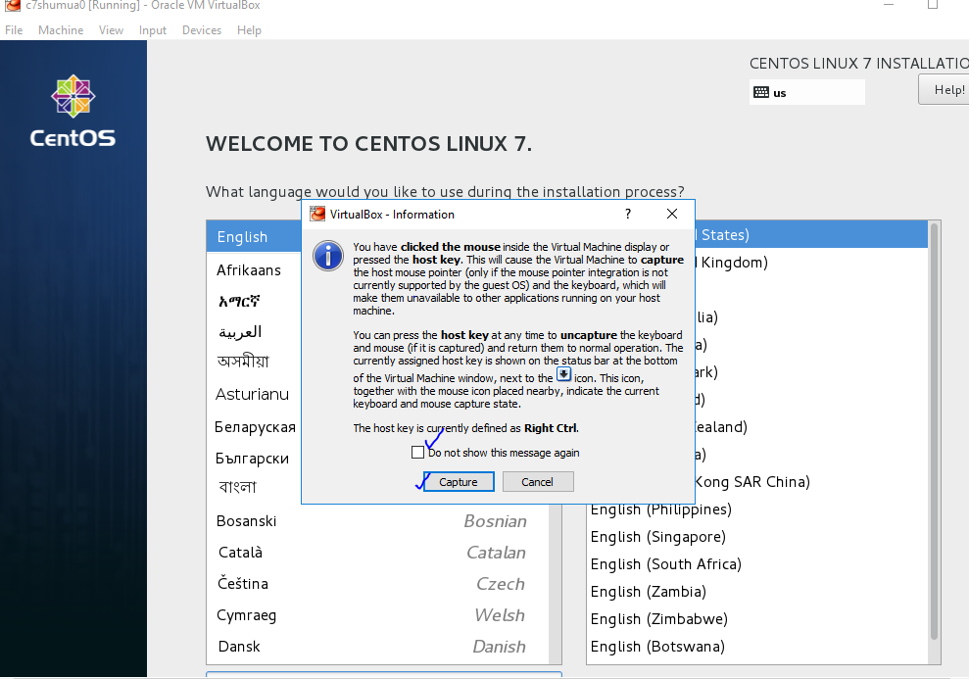

1. Choose United States English. 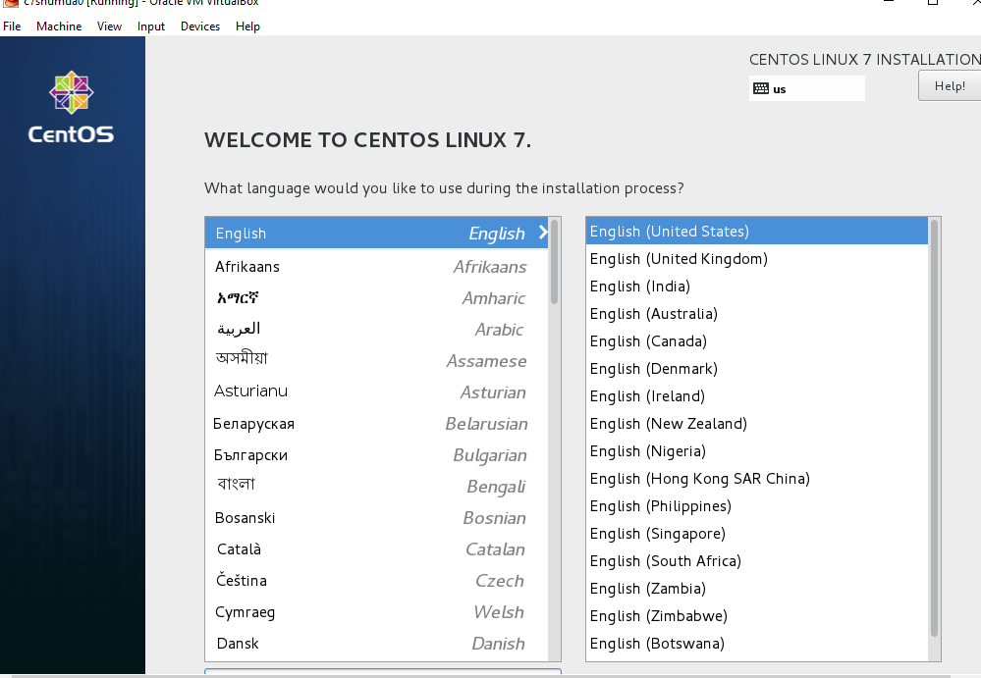
2. these are areas you should edit “Software Selection” = SERVER with GUI, Installation Destination, Network and Hostname.

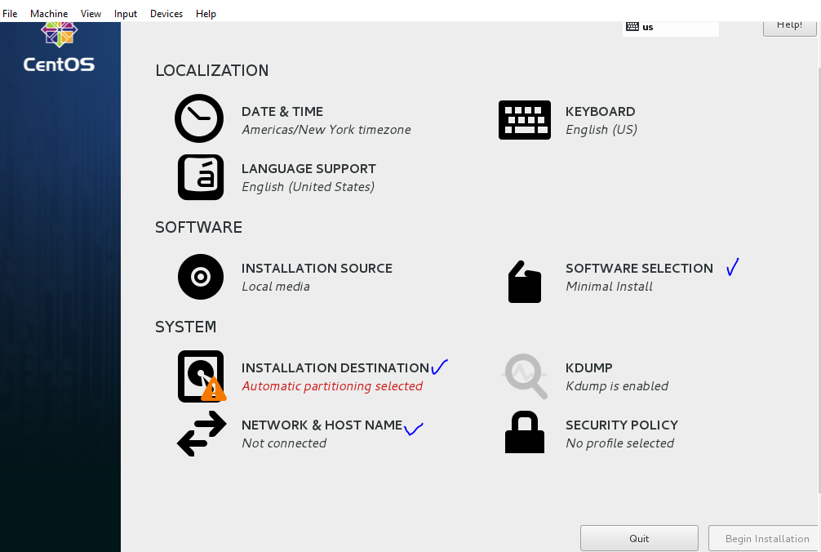

1. 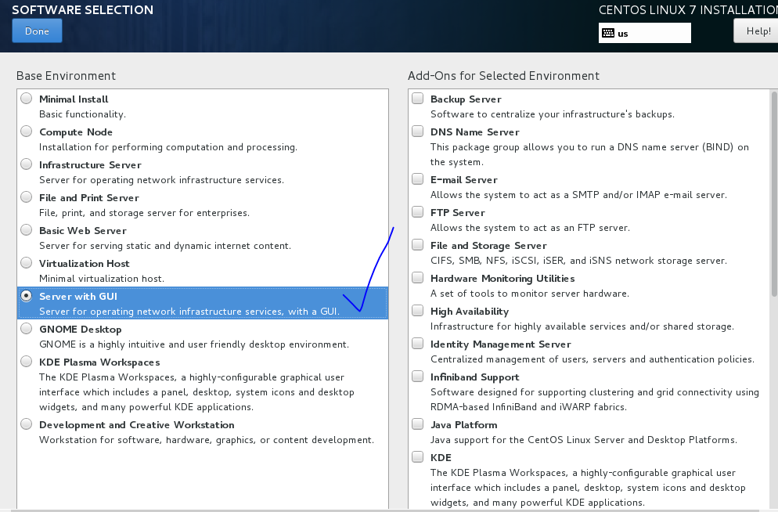

Click “Done”

1. Choose I will configure and click “Done” 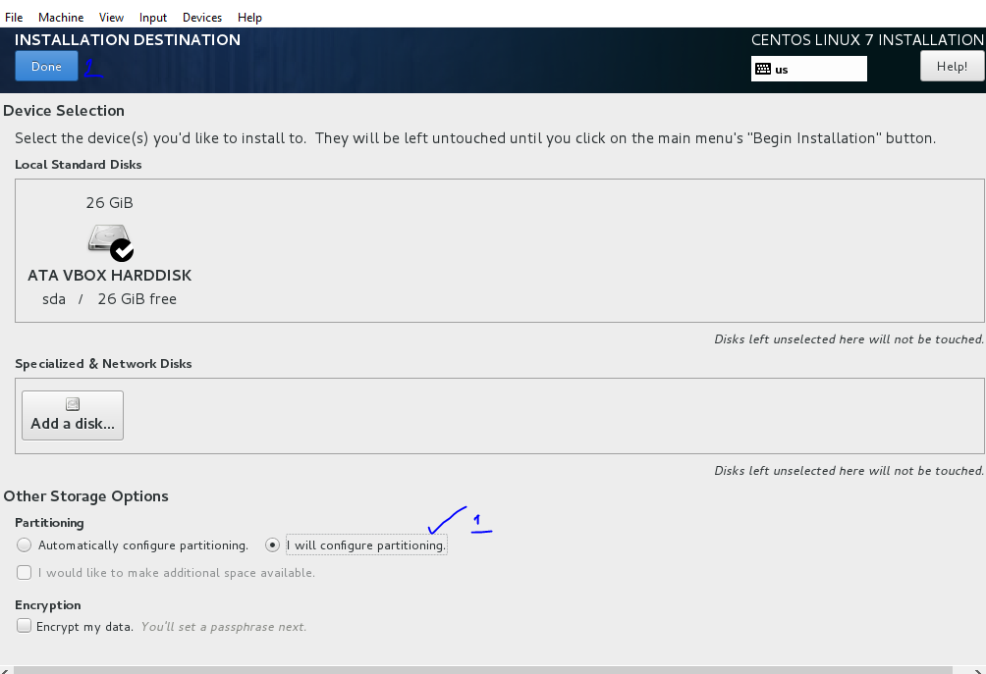
2. Please note marked steps 1,2,3,4 and then add the next file system 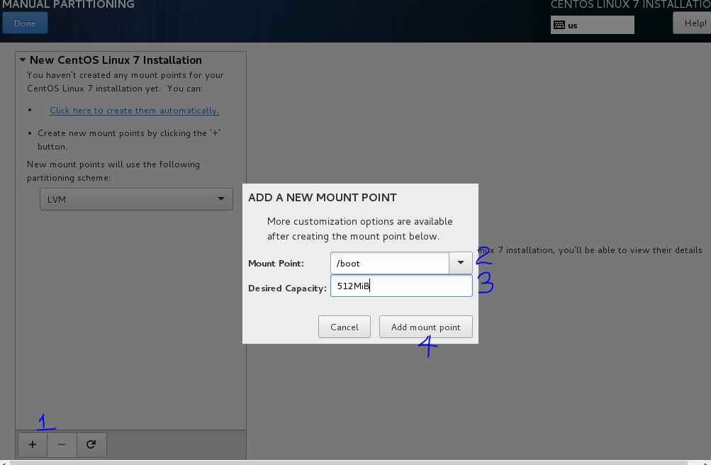
3. Summary of file system allocation 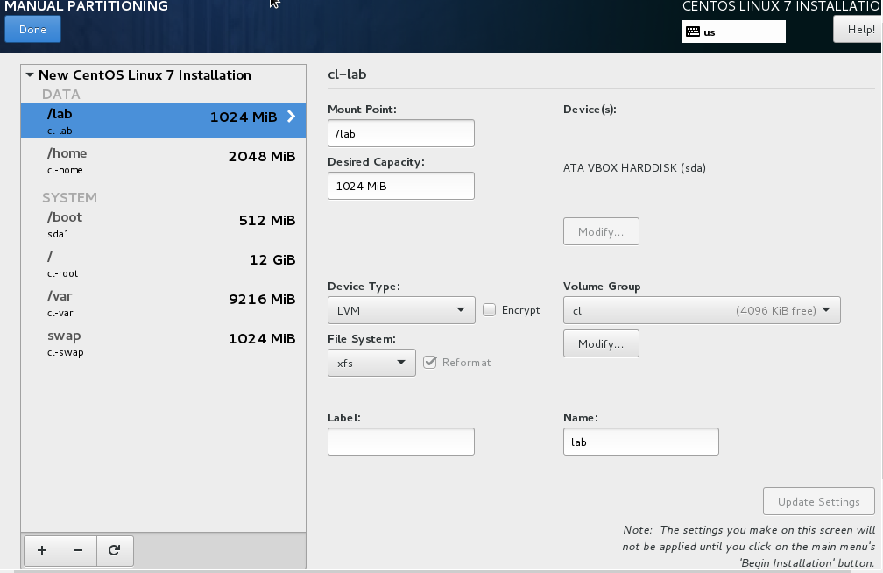
4. Accept Changes 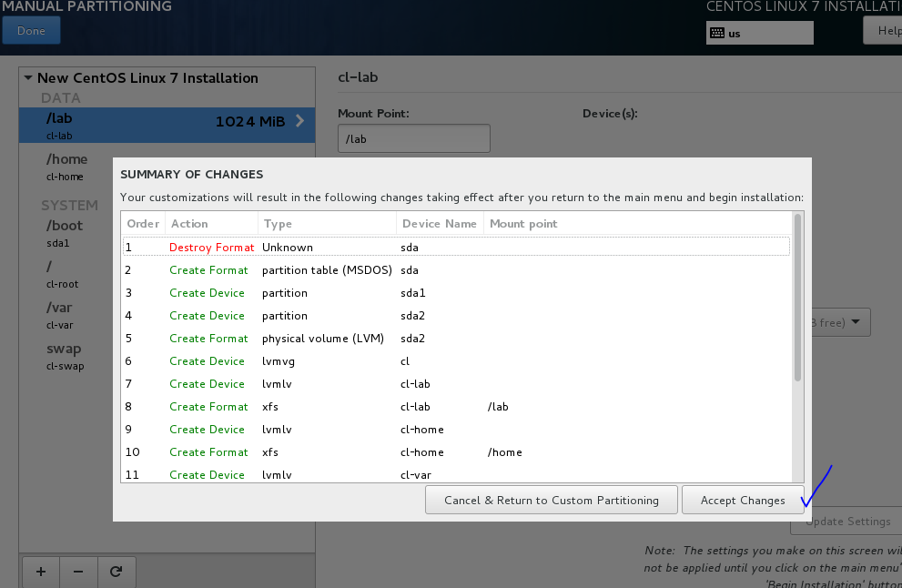
5. Crucial phase “Network Configuration”

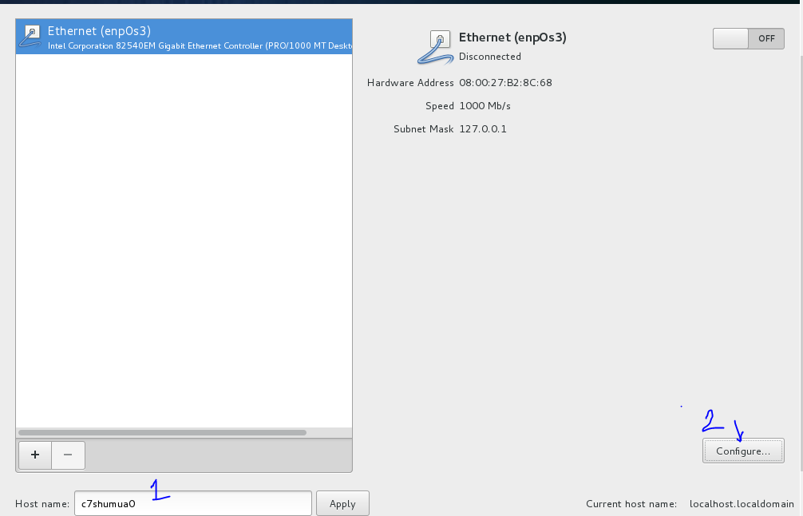

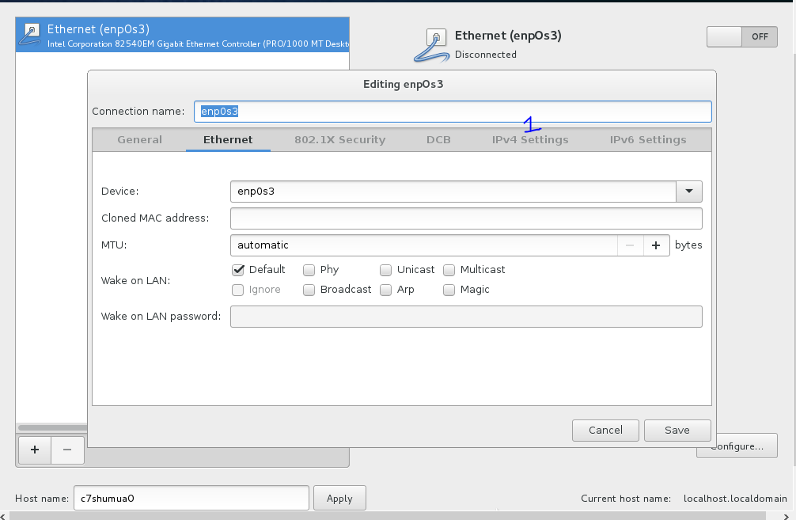

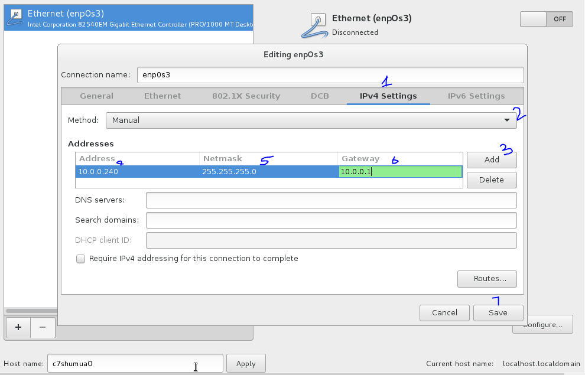aswwsa

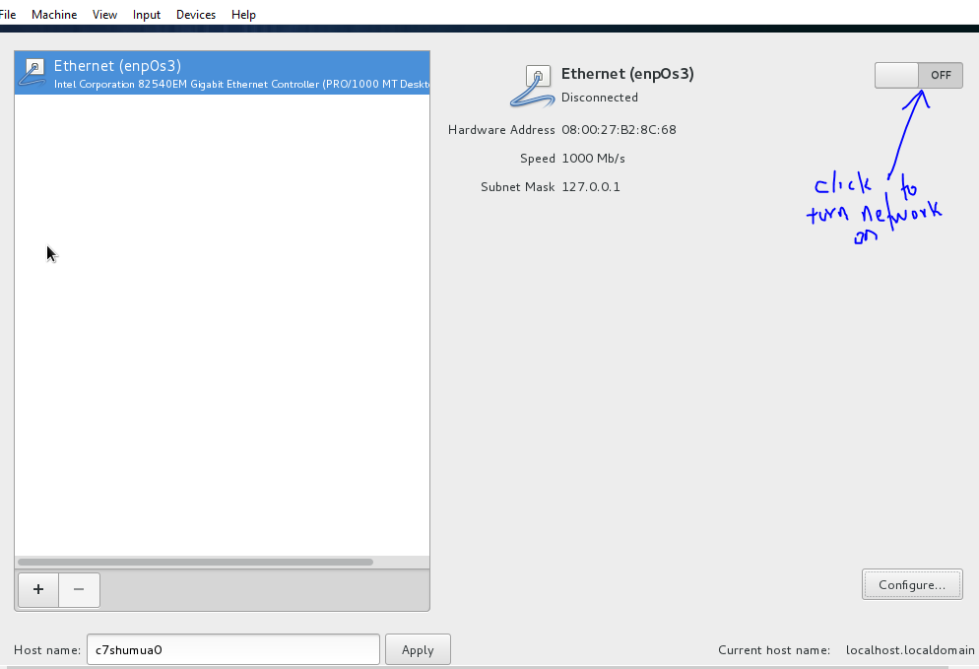

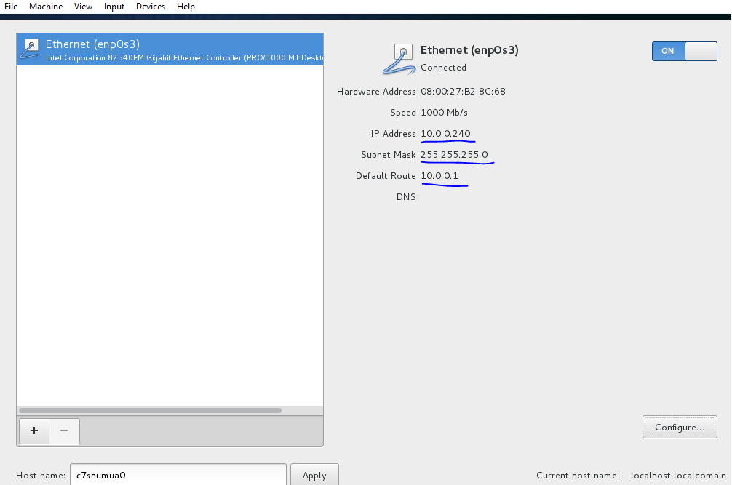

Click on “Done” at top left

Now Click on “Begin Installation”

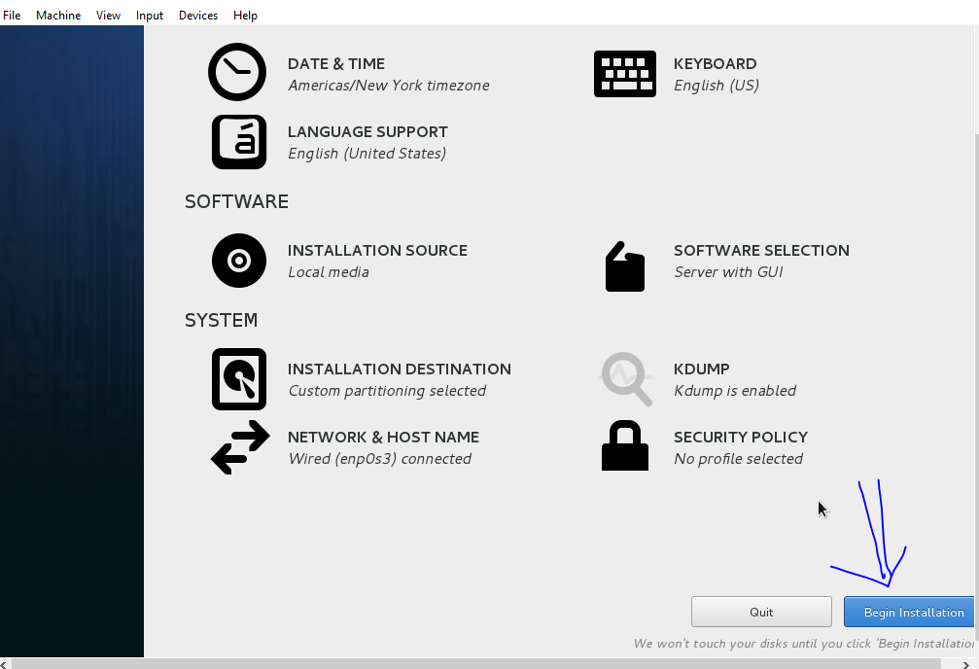

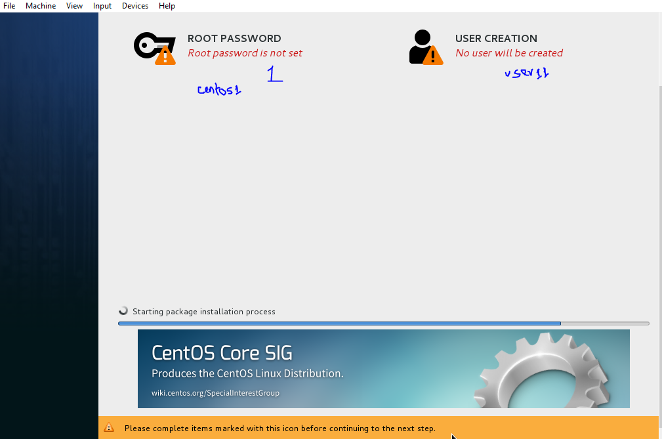

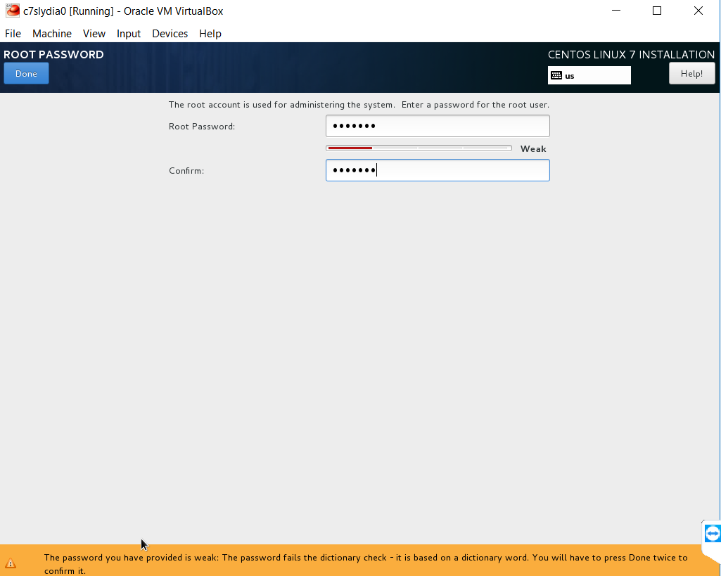

All usernames and passwords must be in lowercase. Please ensure user1 is administrator.

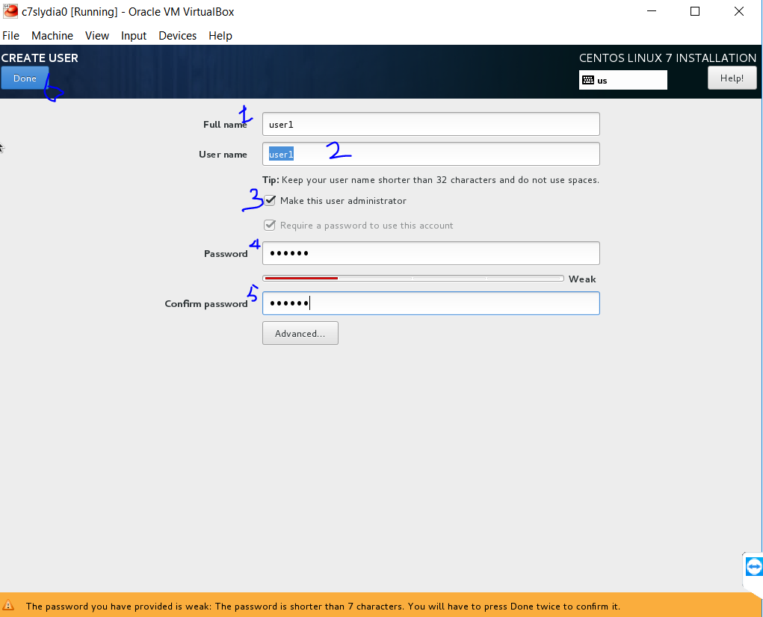

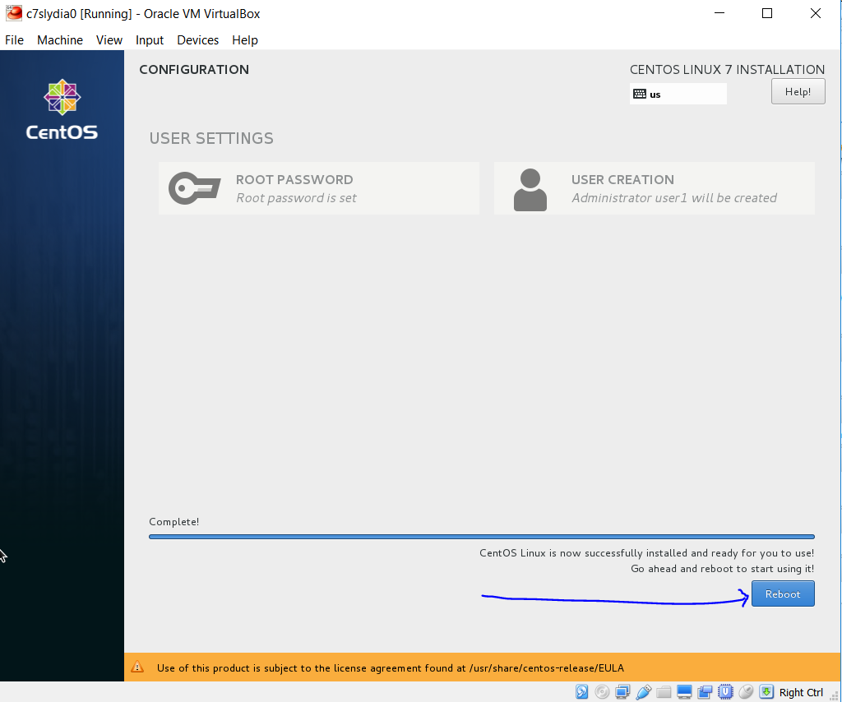

End User License Agreement